Assignment 2 - Potential paper pairs
Identifying influence of worldview in research design (Individual). See the Course Page for detailed information on the assignment requirements.
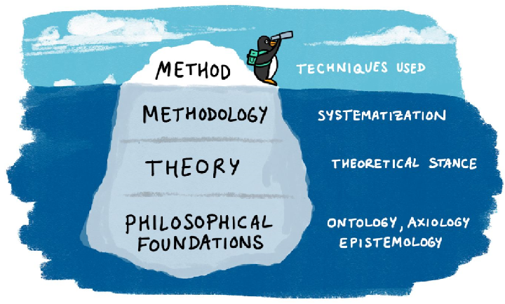
Figure 1. Conceptualizing research method, methodology, theory and philosophical foundations from DeCarlo et al., 2019.
Paired papers address similar climate action topics while using different methodologies and types of data to develop new knowledge from different epistemic or worldview perspectives.
You might find Chapter 7 in Graduate research methods in social work: A project-based approach (DeCarlo et al., 2019) to be useful (see Figure 1), even though it has a focus on social work. To help you stay on track, take field notes as you read to capture ideas and insights and save those that are not part of the immediate assignment for later reflection.
Working with your partner, begin by selecting two peer reviewed research papers from the list below (or of your own choice with the instructor’s approval). Discuss your understanding of the worldviews and the research reported in the papers you compare. You will each submit an original essay of 1500 (+/- 200) words, excluding references.
- Consider what research question was addressed, the suitability of the methods chosen and the worldview that guided the research.
- Include a summary table to present brief comments on the similarities and differences between the papers.
- Discussion: reference at least six other publications in support of your arguments, including one paper addressing Indigenous knowledge and Creswell and Creswell (2018), who use the term worldview as meaning “a basic set of beliefs that guide action”.
Learning Activity 1:
Search and organize: Start a reference library for the course using (i.e., Zotero) and set up a file system to organize data.
Please add all papers to your referencing software to build your climate action library.

Paper Pairs
- Environmental framing
  - Environmental Stewardship: A Conceptual Review and Analytical Framework (Bennett et al., 2018)
  - Faster and safer: Research priorities in water and health (Setty et al., 2019)
- Climate anxiety and future thinking
  - Promnesic futures: Technology, climate, déjà vu (Szpunar, 2021)
  - Thinking about threats: Memory and prospection in human threat management (Bulley et al., 2017)
- Climate anxiety and climate action
  - Climate anxiety: What predicts it and how is it related to climate action? (Whitmarsh et al., 2022)
  - Making sense of climate change—the lived experience of experts (Renouf, 2021)
- Supporting climate action
  - Individual understandings, perceptions, and engagement with climate change: insights from in-depth studies across the world (Wolf & Moser, 2011)
  - Local narratives of change as an entry point for building urban climate resilience. (Marschütz et al., 2020)
- Framing climate justice
  - Planetary justice: A research framework (Biermann & Kalfagianni, 2020)
  - Justice in climate change adaptation planning: conceptual perspectives on emergent praxis (Fünfgeld & Schmid, 2020)
References

Bennett, N. J., Whitty, T. S., Finkbeiner, E., Pittman, J., Bassett, H., Gelcich, S., & Allison, E. H. (2018). Environmental Stewardship: A Conceptual Review and Analytical Framework. Environ Manage, 61(4), 597-614. https://doi.org/10.1007/s00267-017-0993-2
Biermann, F., & Kalfagianni, A. (2020). Planetary justice: A research framework. Earth System Governance. https://doi.org/10.1016/j.esg.2020.100049
Bulley, A., Henry, J. D., & Suddendorf, T. (2017). Thinking about threats: Memory and prospection in human threat management. Conscious Cogn, 49, 53-69. https://doi.org/10.1016/j.concog.2017.01.005
DeCarlo, M., Cory, C., & Agnelli, K. (2019). Graduate research methods in social work: A project-based approach. Open Social Work. https://doi.org/10.21061/msw-research
Fünfgeld, H., & Schmid, B. (2020). Justice in climate change adaptation planning: conceptual perspectives on emergent praxis. Geographica Helvetica, 75(4), 437-449. https://doi.org/10.5194/gh-75-437-2020
Marschütz, B., Bremer, S., Runhaar, H., Hegger, D., Mees, H., Vervoort, J., & Wardekker, A. (2020). Local narratives of change as an entry point for building urban climate resilience. Climate Risk Management, 28. https://doi.org/10.1016/j.crm.2020.100223
Renouf, J. S. (2021). Making sense of climate change—the lived experience of experts. Climatic Change, 164(1-2). https://doi.org/10.1007/s10584-021-02986-5
Setty, K., Loret, J.-F., Courtois, S., Hammer, C. C., Hartemann, P., Lafforgue, M., Litrico, X., Manasfi, T., Medema, G., Shaheen, M., Tesson, V., & Bartram, J. (2019). Faster and safer: Research priorities in water and health. International Journal of Hygiene and Environmental Health, 222(4), 593-606. https://doi.org/https://doi.org/10.1016/j.ijheh.2019.03.003
Szpunar, P. M. (2021). Promnesic futures: Technology, climate, déjà vu. Memory Studies, 14(4), 747-761. https://doi.org/10.1177/17506980211024318
Whitmarsh, L., Player, L., Jiongco, A., James, M., Williams, M., Marks, E., & Kennedy-Williams, P. (2022). Climate anxiety: What predicts it and how is it related to climate action? Journal of Environmental Psychology, 83. https://doi.org/10.1016/j.jenvp.2022.101866
Wolf, J., & Moser, S. (2011). Individual understandings, perceptions, and engagement with climate change: insights from in-depth studies across the world. WIREs Clim Change, 2(4), 547-569. https://doi.org/10.1002/wcc.120

