Updated February 20, 2014
Upload a Video into YouTube
To start, record your video using your smart phone, camera, the webcam on your computer or another recording device. Save it to your computer.
In order to upload a video, you will need a Gmail or YouTube account.
Go to http://www.youtube.com.
Sign in or create an account.
Click on the Upload button from your YouTube channel
Select files to upload
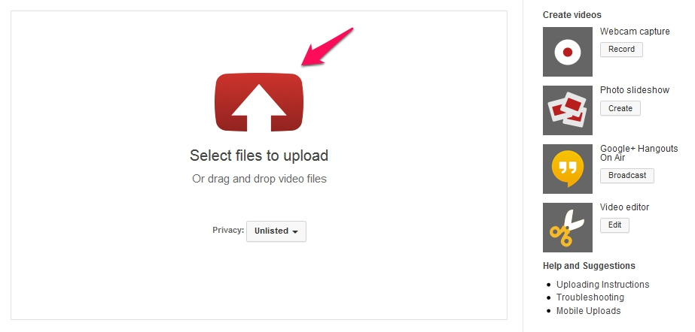
Find the video file on your computer:

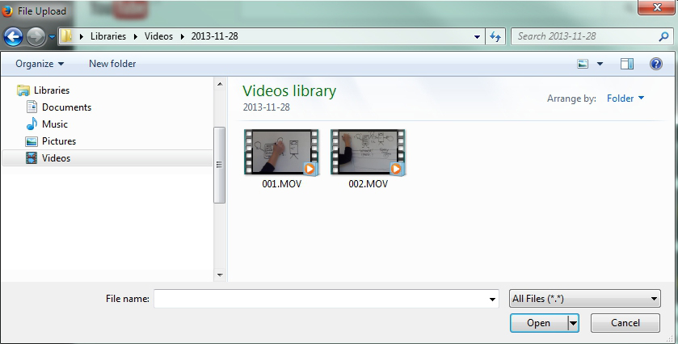

Enter a Title for the video and a Description into the text fields. A description is required in order to see the Save Changes button.

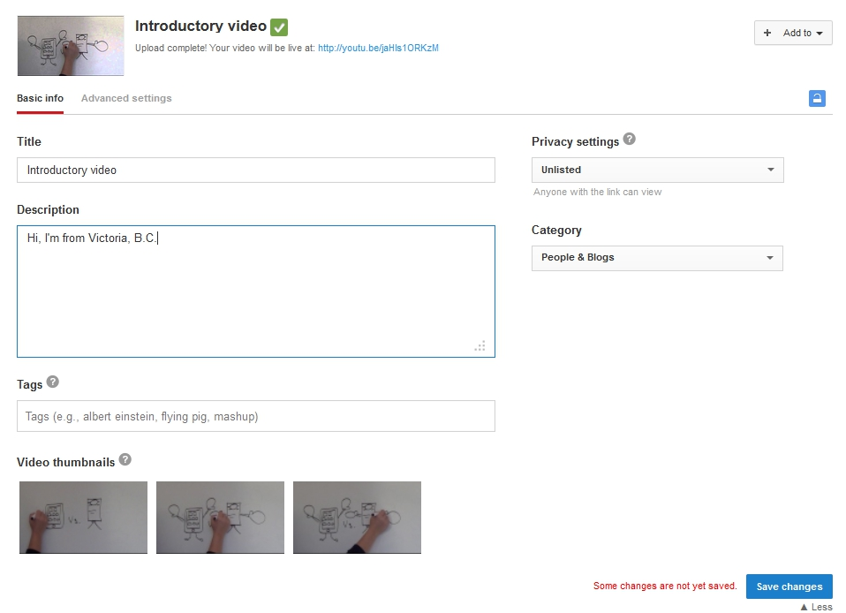
Under Privacy Settings, select Unlisted. This way, the video is not available to the public via a search. This will give you the opportunity to post your video link into your course. Potential viewers will not need to sign in to YouTube to see the video.

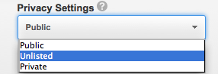
If you want to make the video private, you can send the link to up to 50 people, via their YouTube user name. They will need to sign in to their YouTube account to view the video.

Click on the Advanced Settings tab:
If you want to embed the video in a web page, ensure that there is a check in the “Allow Embedding” option under Distribution Options.
Decide if you want to allow commenting on your video in the Comments and responses section.
Keep the Licensing setting set to “Standard YouTube License”, unless you want to make your video available for re-use under creative commons licensing.
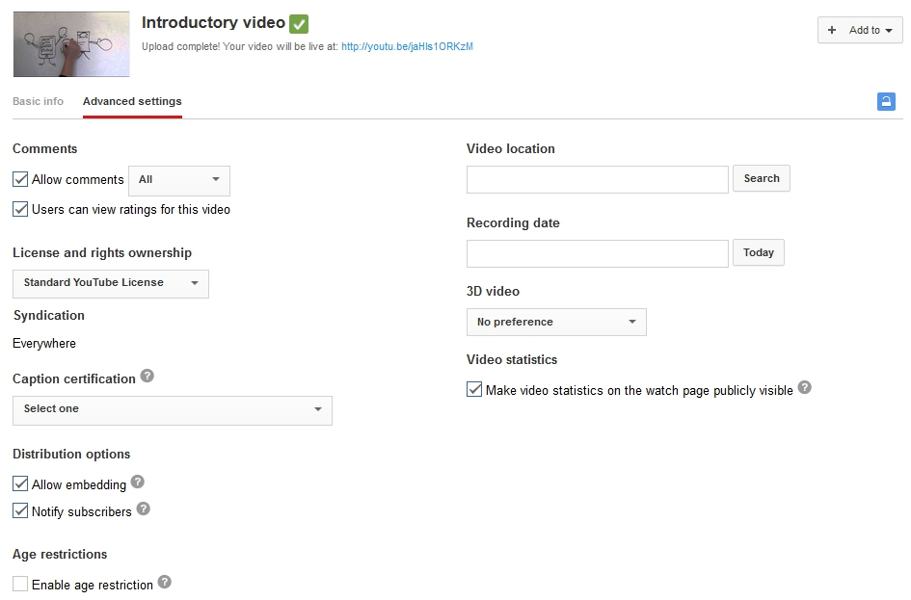
Click on “Save changes” to complete your upload.
Click on the title of your video to review it. You also have the option to edit your video or add annotations.
Copy the link to your video
- There are two ways you can find the link. Copy the link from your top of your browser window, or
- Under the video, click the Share this video tab and copy the link:

Log into your Royal Roads course and post your video link into the forum for introductions.

